Module 10 – MOLP

Exploratory Data Analysis

*In this section, you should perform some data analysis on the data provided to you. Please format your findings in a visually pleasing way and please be sure to include these cuts:*

* *Choose a visualization method (expect 7 nodes and ~24 arcs):*
  + *Make a visual graph of your data on a map (coordinates should be within US borders)*

* + - <https://mymaps.google.com/>
    - Find a map with latitude/longitude and place them approximately
    - Any alternative that gives the same effect
  + *Make a visual graph of your data like what we saw for the sample problem*
    - <https://excalidraw.com>
    - <https://mermaid.live>
    - <https://dreampuf.github.io/GraphvizOnline>
    - Powerpoint

Model Formulation

*Write the formulation of the model into here prior to implementing it in your Excel model. Be explicit with the definition of the decision variables, objective function, and constraints. For this problem, I am only asking that you perform the model formulation for the MOLP model.*

Model Optimized for Equally Weighted Objectives

*Implement your formulation into Excel and be sure to make it neat. This section should include:*

* *A screenshot of your optimized final model (formatted nicely, of course)*
* *A text explanation of what your model is recommending*

*Use a variety of transport methods depending on route distance and cost-effectiveness.* *Three key nodes (based on inflow/outflow patterns) serve as primary hubs in the network, likely due to their centrality or low transport costs: Butter Pecan Bluff Ginger Snap Garden*

*Molly Mint Mountains*

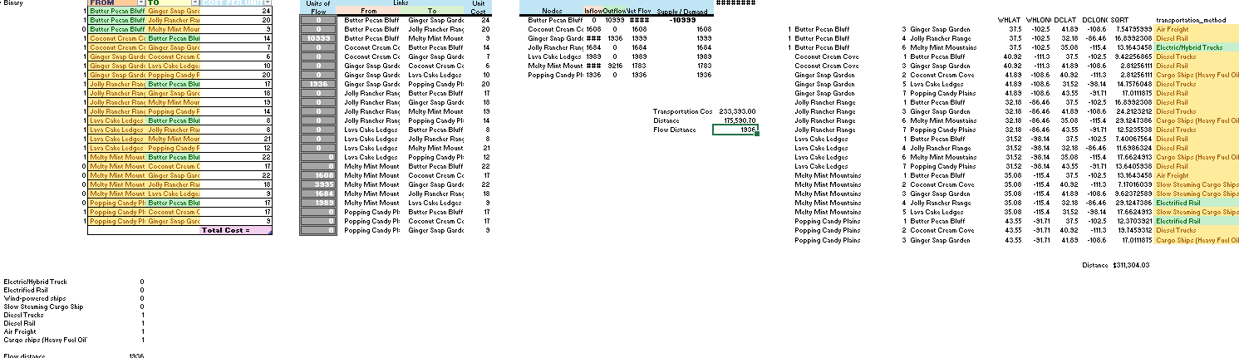

Model with Stipulation

*Please copy the tab of your original model before continuing with the next part to avoid messing up your original solution.*

*Alter the weights of each objective to add weight to match what matters most to you. Perhaps run a few different scenarios to see how the routes change depending on the weights. When you find a weight mix and solution that satisfies you, please write a justification on why you chose the final model/weights and about how a configured model like yours can be used for scenario planning.*